**Creating First Appium Project**

**Desired Capabilities**

- Keys and values encoded in a JSON object, sent by Appium clients (e.g. Java Client) to the server when a new driver session is requested.

- Scripted through code or through the Appium Inspector

- Carries information like,

1. How you want your test to work

2. Device to connect

3. App to work with

Types

- General Capabilities (Common for all drivers)

- Android Only

- iOS Only

Links (Desired capabilities are located under respective GitHub pages of the drivers)

UiAutomator2 (Android) capabilities:

https://github.com/appium/appium-uiautomator2-driver?#capabilities

XCUITest (iOS) capabilities:

<https://github.com/appium/appium-xcuitest-driver#capabilities>

**Vendor Prefix in Appium**

* For adding Desired capabilities Appium have some Standard capabilities but when we add non-standard Desired capability then Appium adds some vendor prefix there
* In below image wherever appium: is added those are Vendor prefix.
* We can add Vendor prefix manually otherwise we have to click on the check box to add vendor prefix automatically.

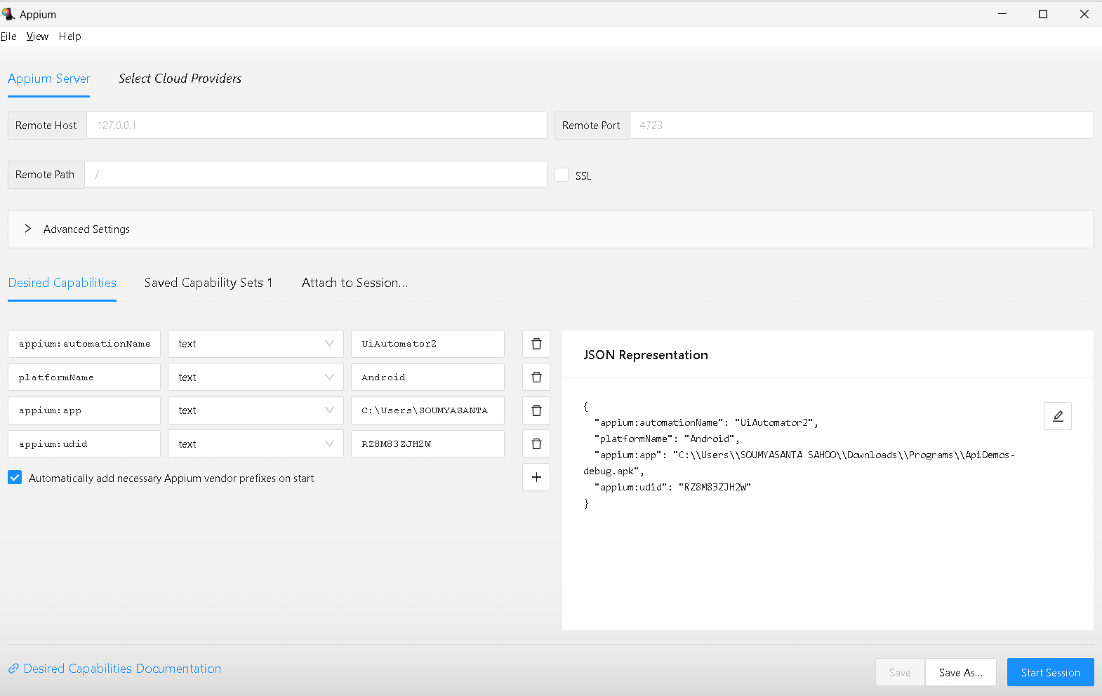

Appium Vendor Prefix

**Why we use Maven Framework**

1. Dependency management

2. Test execution

3. Build Lifecycle Management (validate, compile, package, verify, install, deploy)

4. Supports CI/CD

5. Parallel Execution

**How to get appPackage & appActivity**

Android: appPackage and appActivity desired capabilities

How to find appPackage and appActivity?

Option 1

————

=> Launch app on the device and bring activity in focus

=> Launch terminal/CMD prompt and execute command (for older Android versions): adb shell dumpsys window | grep -E mCurrentFocus

=> Command for Android 10 and above: adb shell "dumpsys activity activities | grep mResumedActivity"

=> On windows, you might have to launch the adb shell first, using command “adb shell”. Then execute the remaining command: "dumpsys activity activities | grep mResumedActivity"

Option 2

————

Install APK Info app

**First Program to Open an App with Real Device**

**package** AppiumBasics;

**import** java.net.MalformedURLException;

**import** java.net.URL;

**import** java.util.concurrent.TimeUnit;

**import** org.openqa.selenium.remote.DesiredCapabilities;

**import** org.testng.annotations.Test;

**import** io.appium.java_client.android.AndroidDriver;

**import** io.appium.java_client.remote.MobileCapabilityType;

**public** **class** OpenApiDemoInRealDeviceTest {

@Test

**public** **void** openAppTest() **throws** MalformedURLException

{

DesiredCapabilities dc=**new** DesiredCapabilities();

//Common Desired Capabilities

dc.setCapability(MobileCapabilityType.***PLATFORM_NAME***, "Android");

dc.setCapability(MobileCapabilityType.***DEVICE_NAME***, "Galaxy M30s");

dc.setCapability(MobileCapabilityType.***AUTOMATION_NAME***, "UiAutomator2");

dc.setCapability(MobileCapabilityType.***UDID***, "RZ8M83ZJH2W");

//Desire Capabilities for Android

dc.setCapability("appPackage", "io.appium.android.apis");

dc.setCapability("appActivity", ".ApiDemos");

//Appium server URL

URL u=**new** URL("http://localhost:4723");

AndroidDriver driver=**new** AndroidDriver(u,dc);

driver.manage().timeouts().~~implicitlyWait~~(20, TimeUnit.***SECONDS***);

driver.quit();

}

}

**First Program to Open an App with Virtual Device (Emulator & Simulator)**

package org.appium.first;

import io.appium.java_client.AppiumDriver;

import io.appium.java_client.android.AndroidDriver;

import io.appium.java_client.ios.IOSDriver;

import io.appium.java_client.remote.MobileCapabilityType;

import org.openqa.selenium.remote.DesiredCapabilities;

import java.io.File;

import java.net.MalformedURLException;

import java.net.URL;

public class CreateDriverSession {

public static void main(String[] args) throws MalformedURLException {

DesiredCapabilities caps = new DesiredCapabilities();

caps.setCapability(MobileCapabilityType.PLATFORM_NAME, "iOS");

caps.setCapability(MobileCapabilityType.DEVICE_NAME, "iPhone 13 Pro Max");

caps.setCapability(MobileCapabilityType.AUTOMATION_NAME, "XCUITest");

caps.setCapability(MobileCapabilityType.UDID, "FDDAF4BC-2C59-4E30-BC16-B05C16E3D29D");

String appUrl = System.getProperty("user.dir") + File.separator + "src" + File.separator + "main"

+ File.separator + "resources" + File.separator + "UIKitCatalog-iphonesimulator.app";

caps.setCapability(MobileCapabilityType.APP, appUrl);

URL url = new URL("http://0.0.0.0:4723");

AppiumDriver driver = new IOSDriver(url, caps);

/* DesiredCapabilities caps = new DesiredCapabilities();

caps.setCapability(MobileCapabilityType.PLATFORM_NAME, "Android");

caps.setCapability(MobileCapabilityType.DEVICE_NAME, "Pixel_5");

caps.setCapability(MobileCapabilityType.AUTOMATION_NAME, "UiAutomator2");

caps.setCapability(MobileCapabilityType.UDID, "emulator-5554");

String appUrl = System.getProperty("user.dir") + File.separator + "src" + File.separator + "main"

+ File.separator + "resources" + File.separator + "ApiDemos-debug.apk";

caps.setCapability(MobileCapabilityType.APP, appUrl);

URL url = new URL("http://0.0.0.0:4723");

AppiumDriver driver = new AndroidDriver(url, caps);*/

}

}

**Open an App with Virtual Device (Emulator & Simulator) using Options class**

package org.appium.first;

import io.appium.java_client.A

ppiumDriver;

import io.appium.java_client.android.AndroidDriver;

import io.appium.java_client.android.options.UiAutomator2Options;

import io.appium.java_client.ios.IOSDriver;

import io.appium.java_client.ios.options.XCUITestOptions;

import io.appium.java_client.remote.MobileCapabilityType;

import org.openqa.selenium.remote.DesiredCapabilities;

import java.io.File;

import java.net.MalformedURLException;

import java.net.URL;

public class CreateDriverSessionUsingOptions {

public static void main(String[] args) throws MalformedURLException {

String appUrl = System.getProperty("user.dir") + File.separator + "src" + File.separator + "main"

+ File.separator + "resources" + File.separator + "UIKitCatalog-iphonesimulator.app";

XCUITestOptions options = new XCUITestOptions().

setDeviceName("iPhone 13 Pro Max").

setAutomationName("XCUITest").

setUdid("FDDAF4BC-2C59-4E30-BC16-B05C16E3D29D").

setApp(appUrl);

URL url = new URL("http://0.0.0.0:4723");

AppiumDriver driver = new IOSDriver(url, options);

/* String appUrl = System.getProperty("user.dir") + File.separator + "src" + File.separator + "main"

+ File.separator + "resources" + File.separator + "ApiDemos-debug.apk";

UiAutomator2Options options = new UiAutomator2Options().

setDeviceName("Pixel_5").

setAutomationName("UiAutomator2").

setApp(appUrl);

URL url = new URL("http://0.0.0.0:4723");

AppiumDriver driver = new AndroidDriver(url, options);*/

}

}

**How to Launch Emulator Automatically**

Capabilities to use:

avd

avdLaunchTimeout

package org.appium.first;

import io.appium.java_client.AppiumDriver;

import io.appium.java_client.android.AndroidDriver;

import io.appium.java_client.ios.IOSDriver;

import io.appium.java_client.remote.MobileCapabilityType;

import org.openqa.selenium.remote.DesiredCapabilities;

import java.io.File;

import java.net.MalformedURLException;

import java.net.URL;

public class CreateDriverSession {

public static void main(String[] args) throws MalformedURLException {

DesiredCapabilities caps = new DesiredCapabilities();

caps.setCapability(MobileCapabilityType.PLATFORM_NAME, "Android");

caps.setCapability(MobileCapabilityType.DEVICE_NAME, "Pixel_XL");

caps.setCapability(MobileCapabilityType.AUTOMATION_NAME, "UiAutomator2");

caps.setCapability(MobileCapabilityType.UDID, "emulator-5554");

caps.setCapability(capabilityName: “avd”, value: “Pixel_XL”);

caps.setCapability(“avdLaunchTimeout”, 180000);

String appUrl = System.getProperty("user.dir") + File.separator + "src" + File.separator + "main"

+ File.separator + "resources" + File.separator + "ApiDemos-debug.apk";

caps.setCapability(MobileCapabilityType.APP, appUrl);

URL url = new URL("http://0.0.0.0:4723");

AppiumDriver driver = new AndroidDriver(url, caps);*/

}

}

**ADB Commands**

adb = android debug bridge

adb is constant

adb devices--> It will fetch UDID.

Why we req. ADB?

-->To establish a communication between your system and device.

1. List connected devices

adb devices

1. If a device is connected start the adb server to be able to interact with the device.

adb start-server

adb kill-server

1. Install an App

adb install [apk_path]

1. Uninstall an App

adb uninstall [package_name]

Example:adb uninstall io.appium.android.apis

1. Pull files from device

adb pull [deviceMObile file location] [local file location]

example:adb pull /storage/emulated/0/sportido_ticket.jpg C:\Users\Srinidhi\Desktop\

1. Write files to device

adb push [local file location] [device file location]

adb push C:\Users\Srinidhi\Desktop\logcat.txt /storage/emulated/0/

1. Taking screenshot

Example: adb shell screencap -p /sdcard/screenshot1.png

adb pull /sdcard/screenshot1.png

adb shell rm /sdcard/screenshot1.png

1. Capturing Videos

adb shell screenrecord /sdcard/NotAbleToLogin.mp4

adb pull /sdcard/NotAbleToLogin.mp4

adb shell rm /sdcard/NotAbleToLogin.mp4

1. Adb logs

adb logcat

adb logcat>D:/April2020/pavan.txt